

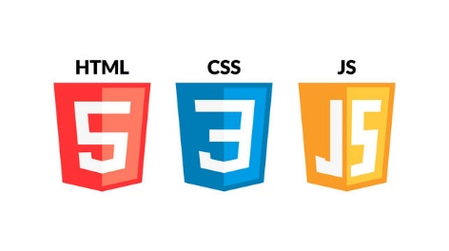

WEB DEVLOPMENT

HTML CSS JS

NOTE’S

Prepare BY-ABHIJEET DESHMUKH

Mo.no.-9096102305/9607655151